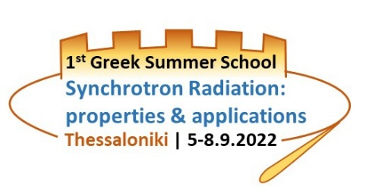 | Registration Form
web page: http://xafslab.physics.auth.gr/srss22.html
e-mail: srss22@physics.auth.gr

Personal Information
First Name |  | Last Name
e-mail |  | Tel. number

Age group | 18-24 |  | 25-34 |  | 35-44 |  | 45-54 |  | 55-64 |  | 65+

Gender | Male |  | Female |  | Other

Address
Address Line 1
Address Line 2
City |  | Postal code
Country

Education-occupation
Education | B.Sc. degree |  | M.Sc. degree |  | Ph.D. degree

Employment | Employed |  | Unemployed |  | retired

Profession

Documents and payment information
Registration fees: | 150 € |  | 100 € (B.Sc./M.Sc./Ph.D. student)
They cover teaching material, refreshments/coffees, and lunches during workshop. They do not cover accommodation expenses.
Payment by bank transfer
Piraeus Bank
IBAN: GR9401722020005202057157381
SWIFT BIC: PIRBGRAA
Please mention your name and the project Nr: 74527
Please attach
- the Proof of payment of the tuition fees
- verification of status [in case of reduced fee (100 €)]

Please send the filled registration form in word format to: srss22@physics.auth.gr

